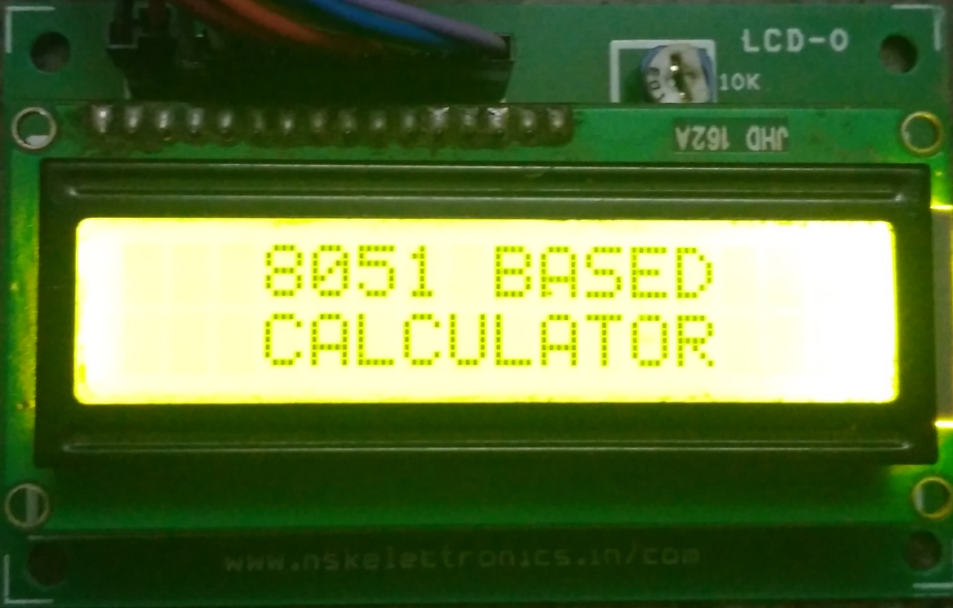 **8051 BASED CALCULATOR**

**Submitted By:**

PRATHIMA K R

RAVICHANDRA T

YASHASWINI